|  |
| --- |
| NetObjex |
| Liquidity Management |
| Beginner’s Guide |

|  |
| --- |
| Anand A  1-16-2019  Intended Audience: Beginners to Liquidity Management |

Contents

Introduction 1

Definition 1

Need for Liquidity Management System 1

Challenges that can be overcome by corporates 1

Role of Banks in Liquidity Management: 1

Ideal Liquidity Management Solution: 2

Features Supported 3

Setup 3

Techniques Involved in Liquidity Management: 3

# Introduction

Financial liquidity is the ability of the financial institution to meet its cash needs through its:

* Cash balance
* Receivables
* Asset conversion into cash without loss in value

# Definition

Liquidity Management (LM) is the ability to most optimally manage an organization's working capital across locations and functions (Cash in hand).

The core purpose of LM for a financial institution is being able to:

* Obtain funding at minimum costs
* Invest surplus cash in long term and short term investment to maximize returns
* Reduce idle cash

# Need for Liquidity Management System

* Balance the deficit and surplus cash positions
* Apply lowest cost of capital for funding daily cash needs
* Invest surplus funds
* Generate holistic corporate reports
* Minimize idle balances in all operative accounts across locations
* Manage multiple geographic locations of corporate organizations
* Manage multiple geographic regulations
* Manage multiple time lines and currencies involved in business
* Manage multiple lines of business

# Challenges that can be overcome by corporate

* Fluctuating currency Business spanning multiple time lines
* Increasing financial transaction volumes
* Adhering to regulations across various geographic locations
* Following multiple business models in different organizations
* Monitoring, tracking and controlling liquidity

# Role of Banks in Liquidity Management:

Banks play an important role in corporate liquidity management by providing:

* account management services
* advisory services
* product for maximum cash utilization
* product for on demand borrowing to meet cash demand at minimum cost

Banks enable corporate to:

* streamline the multiple banking connections
* offer holistic bird’s eye view of liquidity
* minimize the overdraft

Figure 1: Liquidity Management in Banks

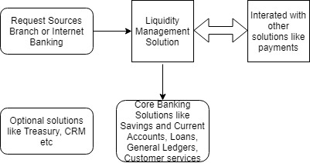

# Ideal Liquidity Management Solution:

It empowers banks to offer comprehensive range of services to their corporate customers to identify, manage, and optimize liquidity.

Features of Ideal Liquidity Management System (LMS):

* Enables banks to offer apt liquidity management services to corporate customers
* Enables corporate customers to increase interest earnings using techniques such as notional pooling and target balancing
* Enables corporate customers to view dashboard representation of liquidity positions, rules and simulate cash positions thus improving decision making

Figure 2: Ideal Liquidity Management Solution

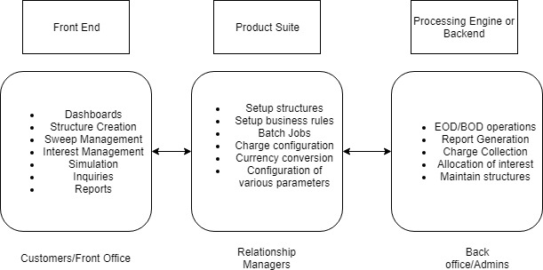

# Features Supported

* Supports internal, multi-entity, multi-bank and multi-currency
* Supports creation of multilevel pooling to optimize and distribute interest benefits
* Supports nested target balancing structures
* Supports zero balancing and target balancing
* Supports better interest returns on the balances held in the pool

# Setup

1. Charge Setup – Setup various charges for various services offered
2. Exception Setup – Setup action to be taken in case of exceptions
3. Account ID Creation Code Setup – Setup parameters for account ID creation
4. Reference Code Setup – Setup reference codes for standardization across platform

# Techniques Involved in Liquidity Management:

The two most common liquidity management techniques adopted by the bank are:

1. Target Balancing
2. Notional Pooling

Target Balancing or Account Sweeping

Target Balancing is transfer of funds from different accounts into central accounts to enhance the efficiency of cash management. Sweeping is done based on various attributes in sweep structure like sweep contracts, sweep features, sweep processes, sweep arrangement etc.

Figure 3: Target Balancing

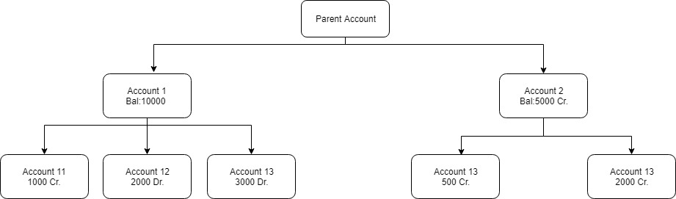

For E.g.

* There are three levels of hierarchy.
* In the case of zero target balance - as the net balances of the subsidiary accounts, 12 and 13 are in deficit, funds are transferred from the group account 1 to the subsidiary accounts to cover the individual deficits.
* Conversely, the surplus funds in the sub account 11 are transferred to the group account 1. The net balance of group Account 1 post the sweeps is 6000.

Notional pooling

Notional Pooling is offsetting of multiple balances at a single bank for the purpose of calculating interest on net balance. There is no tangible movement of funds. Interest is usually debited/credited to a designated master or header account.

Note: Key difference between these techniques is that sweeping involves physical movement of money between two accounts whereas pooling is aggregating the balance notionally across multiple accounts without financial transaction.